**DevOps Lab**

**Exercise 1**

Trisha Balakrishnan

21011102105

IoT-B

1. **Exploring Git Commands through Collaborative Coding – Basic Git commands.**
2. Create a Repository

* Setting Up Git Repository named “Master”

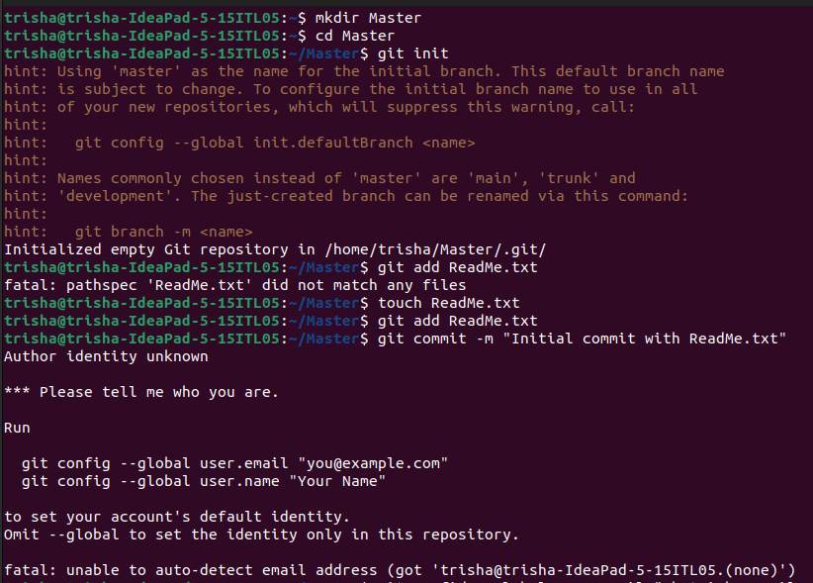

1. Add and Commit Changes

* Create a new text file named ReadMe.txt using any text editor.

1. 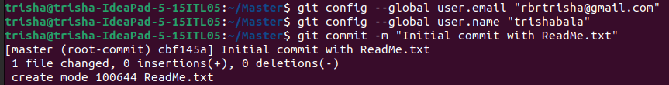Exploring history

* Modify/add content to the textfile.

1. Branching and merging

* Create a new branch named "Updated_ReadMe" and commit the changes in the branch.
* Merge the changes from the Updated_ReadMe branch into the Master branch.

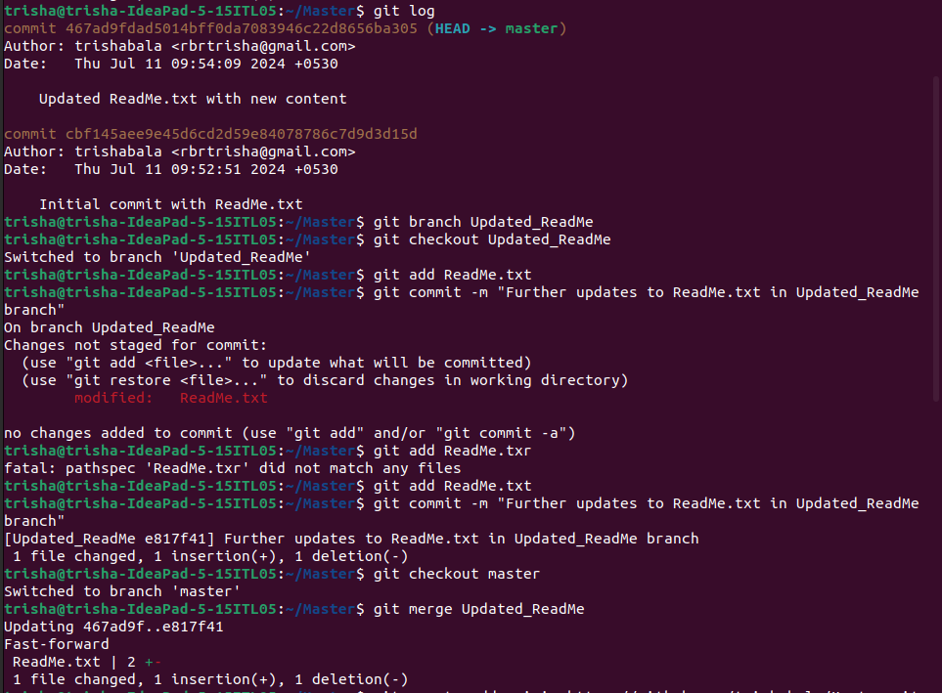

1. Collaborating with Remote Repositories

* Link your local repository to the remote repository

1. Push Changes

* Push your local commits to the remote repository

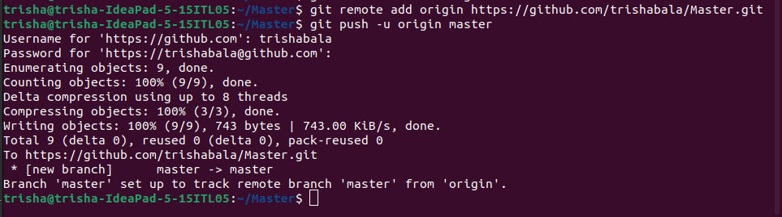

**DevOps Lab**

**Exercise 1**

1. **Implement GitHub Operations using Git.**
   1. **Cloning a Repository**

* Clone the repository of your project from github

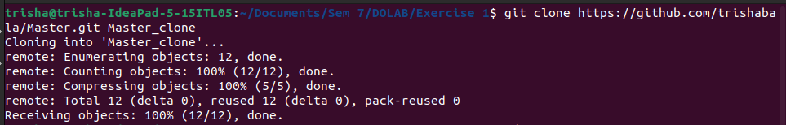

* 1. **Making Changes and Creating a Branch**
* Navigate into the cloned repository, do the necessary changes and check the status of the repository

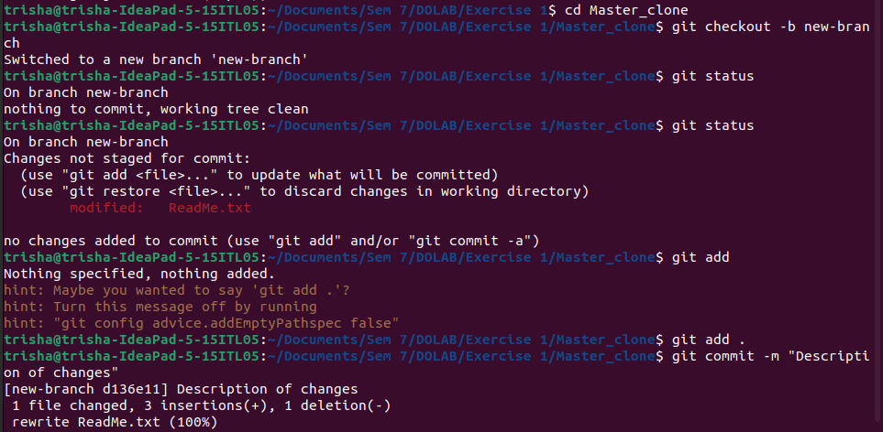

* 1. **Pushing Changes to GitHub**
* Add Repository URL in a variable



* Push the local branch to the repository

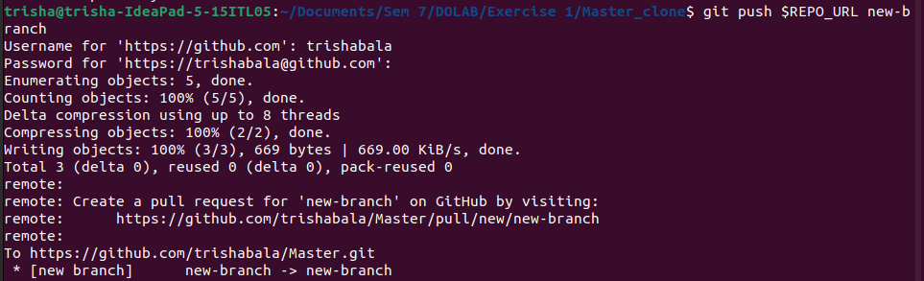

* 1. **Collaborating through Pull Requests**
* Create a pull request on GitHub
* Choose the base branch and compare it with the branch
* Review the changes and merge the pull request.
* Add a title and description for the pull request
* Assign reviewers
* Reviewers approve the pull request, merge it into the base branch.
  1. **Syncing Changes**
* After the pull request is merged, update your local repository

